**CYCLE 4**

1. **Create a Graphics package that has classes and interfaces for figures Rectangle, Triangle, Square and Circle. Test the package by finding the area of these figures**.

**Code**

Area.java

import package_graphics.*;

import java.util.Scanner;

public class Area

{

public static void main(String []args)

{

package_graphics testObj = new package_graphics();

int l,h,r,a,c,d;

Scanner s=new Scanner(System.in);

System.out.println("\tAditya Suresh\n\t23mca004\n\t09/04/2024");

System.out.println("Enter the length for rectangle");

l=s.nextInt();

System.out.println("Enter the breadth for rectangle");

h=s.nextInt();

System.out.println("Enter the radius of circle");

r=s.nextInt();

System.out.println("Enter the side for Square");

a=s.nextInt();

System.out.println("Enter the breadth for triangle");

c=s.nextInt();

System.out.println("Enter the height for triangle");

d=s.nextInt();

System.out.println("Area of rectangle="+testObj.recArea(l,h));

System.out.println("Area of circle="+testObj.cirArea(r));

System.out.println("Area of square="+testObj.squArea(a));

System.out.println("Area of triangle="+testObj.triArea(c,d));

}

}

package_graphics.java

package package_graphics;

interface interface_graphics

{

public float recArea(int l, int h);

public float cirArea(int r);

public float squArea(int a);

public float triArea(int l, int h);

}

public class package_graphics implements interface_graphics

{

public float recArea(int l, int h)

{

return l*h;

}

public float cirArea(int r)

{

return r*r*(float)3.14;

}

public float squArea(int a)

{

return a*a;

}

public float triArea(int l, int h)

{

return l*h*(float)(.5);

}

}

**Output**

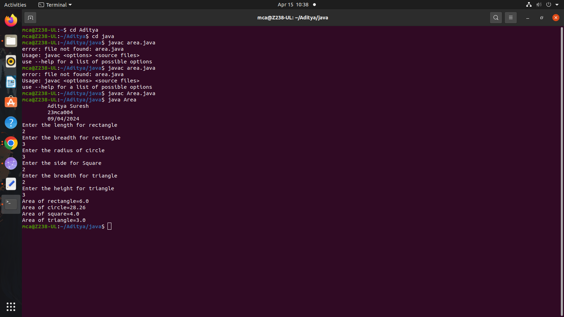

1. **Create an Arithmetic package that has classes and interfaces for the 4 basic arithmetic operations. Test the package by implementing all operations on two given numbers**

**Code**

ArithmeticMain.java

import arithmetic.ArithmeticOperations;

import java.util.Scanner;

public class ArithmeticMain {

public static void main(String[] args) {

System.out.println("\tAditya Suresh\n\t23mca004\n\t15/04/2024");

System.out.println();

ArithmeticOperations operations = new ArithmeticOperations();

Scanner scanner = new Scanner(System.in);

System.out.print("Enter the first number: ");

double num1 = scanner.nextDouble();

System.out.print("Enter the second number: ");

double num2 = scanner.nextDouble();

System.out.println("Addition: " + operations.add(num1, num2));

System.out.println("Subtraction: " + operations.subtract(num1, num2));

System.out.println("Multiplication: " + operations.multiply(num1, num2));

System.out.println("Division: " + operations.divide(num1, num2));

}

}  
Addition.java

package arithmetic;

public interface Addition {

public double add(double num1, double num2);

}

ArithmeticOperations.java

package arithmetic;

public class ArithmeticOperations implements Addition, Subtraction, Multiplication, Division {

@Override

public double add(double num1, double num2) {

return num1 + num2;

}

@Override

public double subtract(double num1, double num2) {

return num1 - num2;

}

@Override

public double multiply(double num1, double num2) {

return num1 * num2;

}

@Override

public double divide(double num1, double num2) {

if (num2 == 0) {

throw new ArithmeticException("Division by zero error!");

}

return num1 / num2;

}

}

Division.java

package arithmetic;

public interface Division {

public double divide(double num1, double num2);

}  
Multiplication.java

package arithmetic;

public interface Multiplication {

public double multiply(double num1, double num2);

}  
Subtraction.java

package arithmetic;

public interface Subtraction {

public double subtract(double num1, double num2);

}

**Output**

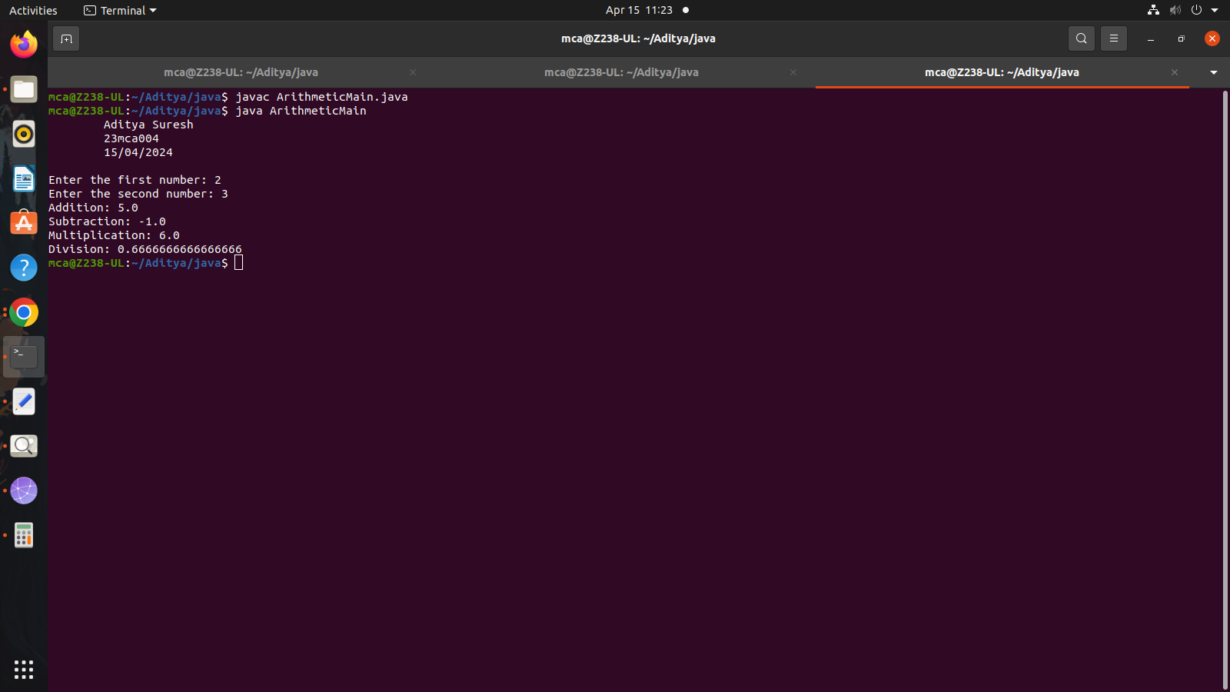

1. **Write a user defined exception class to authenticate the user name and password**

**Code**

import java.util.Scanner;

class authException extends Exception{

public authException(String s) {

super(s);

}}

public class Userpass

{

public static void main(String[] args) {

System.out.println("\tAditya Suresh\n\t23mca004\n\t15/04/2024");

String username = "student";

String passcode = "student123";

String user_name,password;

Scanner sc = new Scanner(System.in);

try

{

System.out.println("Enter the username:");

user_name = sc.nextLine();

System.out.println("Enter the password:");

password = sc.nextLine();

if(username.equals(user_name) && passcode.equals(password))

{

System.out.println("Authentication successful...");

}

else

throw new authException("Invalid user credentials");

}

catch(authException e)

{

System.out.println("Exception caught "+e);

}}}

**Output**

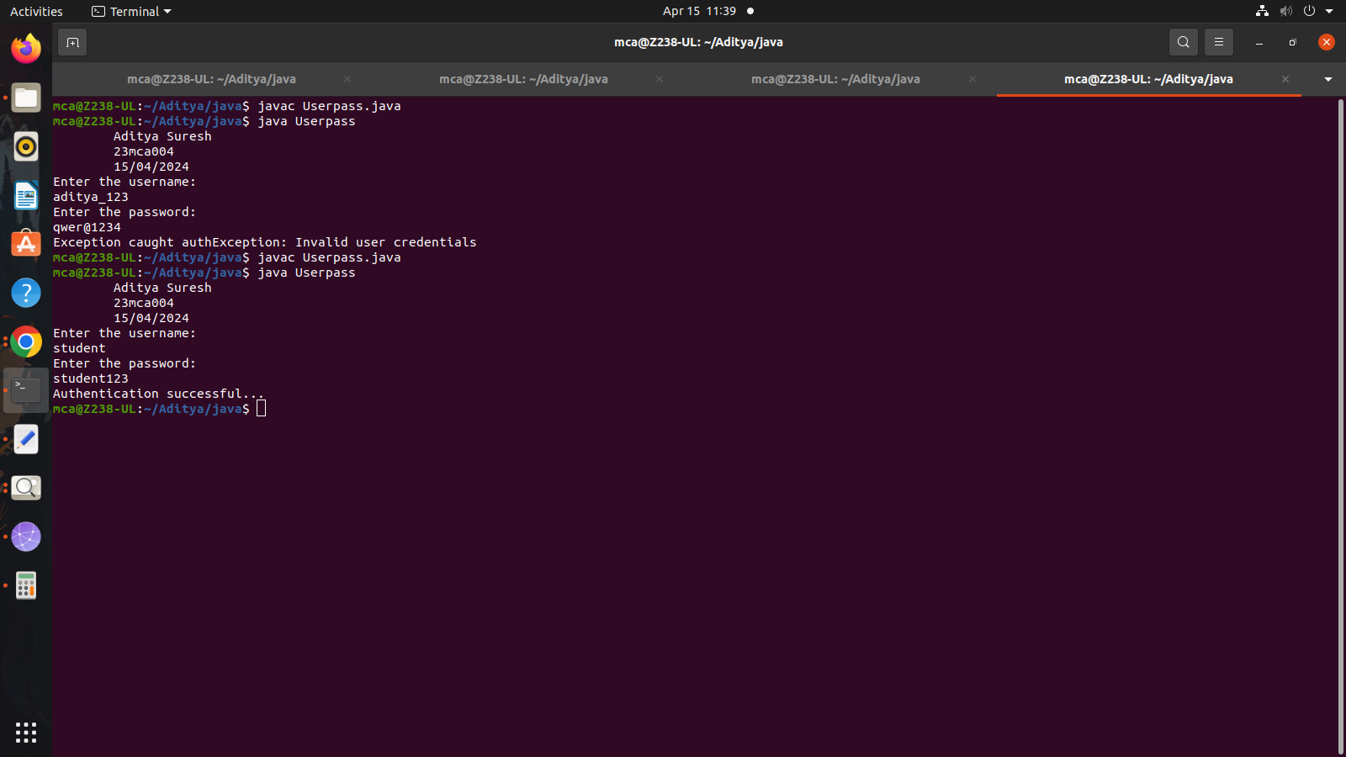

1. **Find the average of N positive integers, raising a user defined exception for each negative input.**

**Code**

import java.util.Scanner;

class NegException extends Exception

{

public NegException(String s)

{

super(s);

}

}

public class Avg_of_n {

public static void main(String[] args)

{

System.out.println("\tAditya Suresh\n\t23mca004\n\t15/04/2024");

int i;

double sum=0,avg=0;

Scanner sc=new Scanner(System.in);

System.out.println("Enter n numbers:");

int n=sc.nextInt();

for(i=1;i<=n;i++)

{

try

{

System.out.println("Enter number"+i);

int a=sc.nextInt();

if(a<0)

{

i--;

throw new NegException("Negative numbers not allowed,Try again");

}

else

{

sum=sum+a;

}

}

catch(NegException e)

{

System.out.println("NEGETIVE EXCEPTION OCCURED:"+e);

}

}

avg=sum/n;

System.out.println("Average is "+avg);

sc.close();

}

}

**Output**

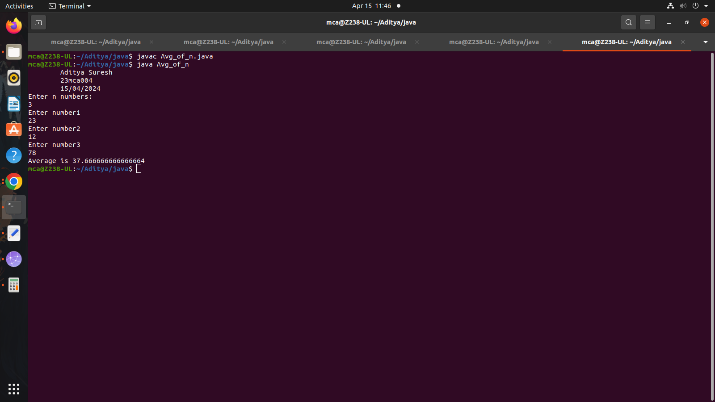

1. **Program to remove all the elements from a linked list**

**Code**

import java.util.*;

public class Linkedlist {

public static void main(String[] args){

System.out.println("\tAditya Suresh\n\t23mca004\n\t15/04/2024");

LinkedList<String> L=new LinkedList<>();

L.add("Gold");

L.add("Silver");

L.add("Bronze");

L.add(0,"Olympics Medals");

System.out.println(L);

L.remove("Bronze");

System.out.println(L);

L.remove(2);

System.out.println(L);

L.removeLast();

System.out.println(L);

L.removeFirst();

System.out.println(L);

}

}

**Output**

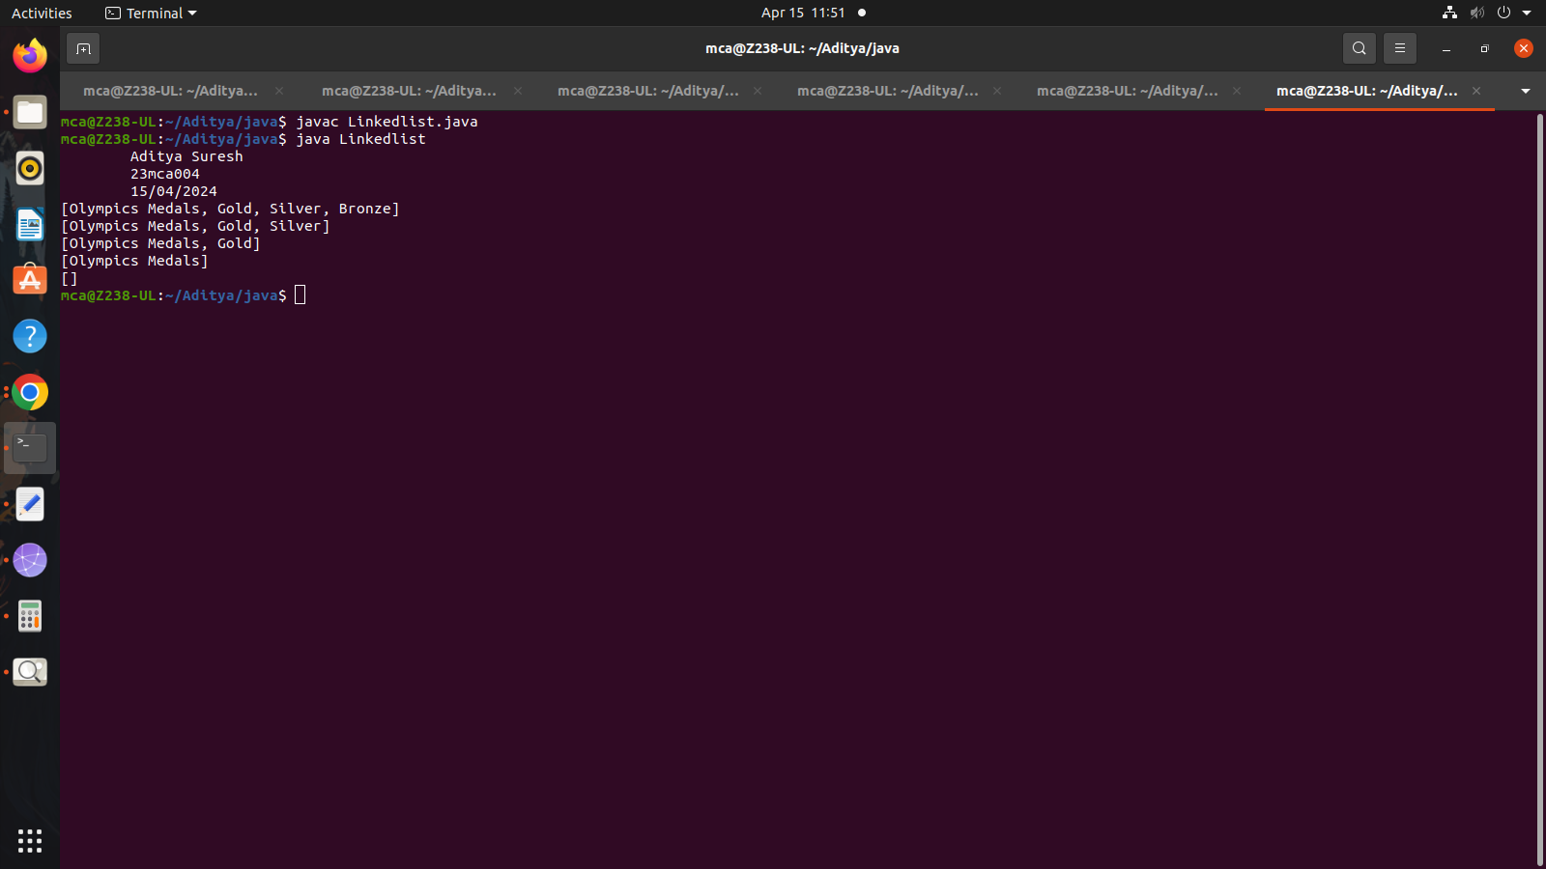

1. **Program to remove an object from the Stack when the position is passed as parameter**

**Code**

import java.util.Stack;

public class Remove_obj {

public static void removeElementAtPosition(Stack<String> stack, int position) {

if (position >= 1 && position <= stack.size()) {

Stack<String> tempStack = new Stack<>();

// Remove elements from the original stack until the desired position is reached

for (int i = 1; i < position; i++) {

tempStack.push(stack.pop());

}

// Remove the element at the desired position

stack.pop();

// Restore the remaining elements back to the original stack

while (!tempStack.isEmpty()) {

stack.push(tempStack.pop());

}

System.out.println("Element at position " + position + " removed successfully.");

} else {

}

}

public static void main(String[] args) {

System.out.println("\tAditya Suresh\n\t23mca004\n\t15/04/2024");

Stack<String> stack = new Stack<>();

stack.push("Element 1");

stack.push("Element 2");

stack.push("Element 3");

stack.push("Element 4");

stack.push("Element 5");

int positionToRemove = 3;

System.out.println("Before removal: " + stack);

removeElementAtPosition(stack, positionToRemove);

System.out.println("After removal: " + stack);

}

}

**Output**

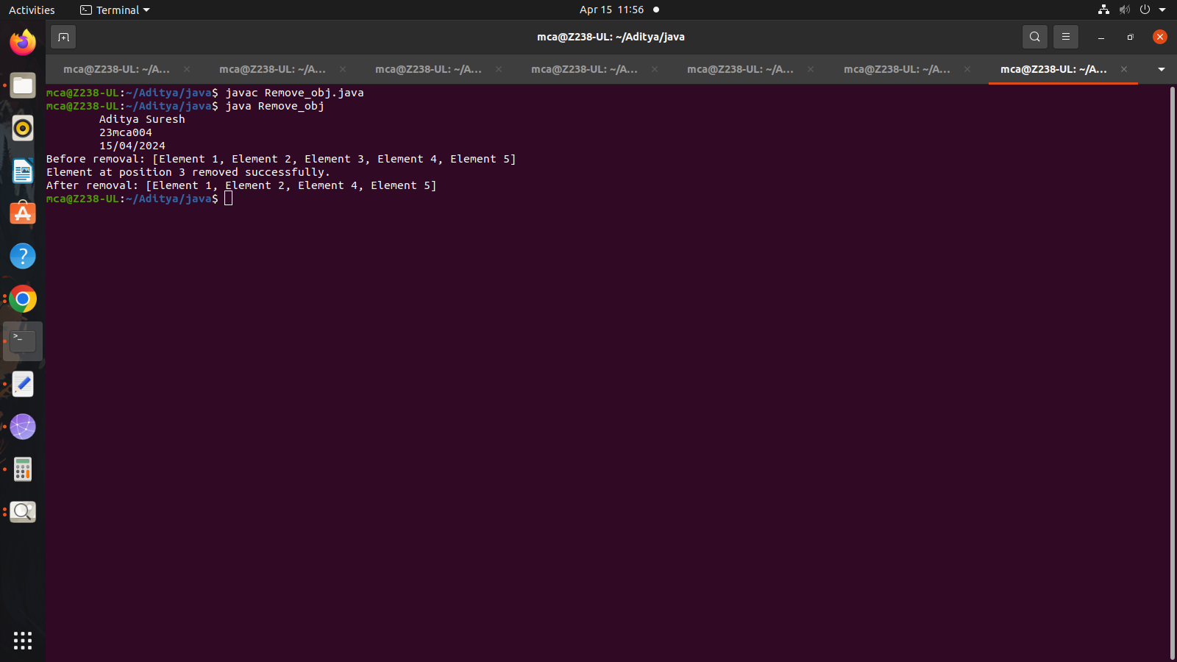

1. **Write a Java program to compare two hash set**

**Code**

import java.util.HashSet;

import java.util.Scanner;

import java.util.Set;

public class Compare_hash{

public static void main(String[] args) {

System.out.println("\tAditya Suresh\n\t23mca004\n\t15/04/2024");

Set<Integer> set1 = new HashSet<>();

Set<Integer> set2 = new HashSet<>();

Scanner scanner = new Scanner(System.in);

// Input for Set 1

System.out.print("Enter the number of elements in Set 1: ");

int numElements1 = scanner.nextInt();

System.out.println("Enter the elements for Set 1:");

for (int i = 0; i < numElements1; i++) {

int element = scanner.nextInt();

set1.add(element);

}

// Input for Set 2

System.out.print("Enter the number of elements in Set 2: ");

int numElements2 = scanner.nextInt();

System.out.println("Enter the elements for Set 2:");

for (int i = 0; i < numElements2; i++) {

int element = scanner.nextInt();

set2.add(element);

}

// Comparison

boolean isEqual = set1.equals(set2);

// Output

System.out.println("Set 1: " + set1);

System.out.println("Set 2: " + set2);

if (isEqual) {

System.out.println("Set 1 and Set 2 are equal.");

} else {

System.out.println("Set 1 and Set 2 are not equal.");

}

scanner.close();

}

}

**Output**

